INFRARED IC HEATER

Smart Reflow Oven User Manual

Model: T-962A

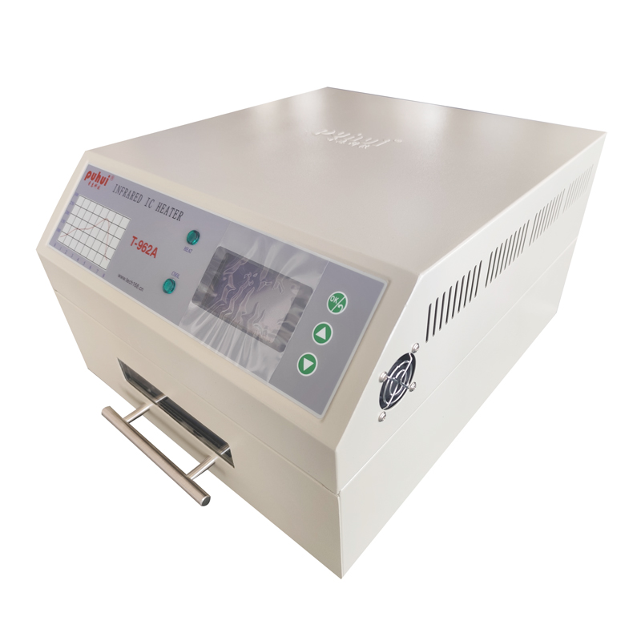

SHANDONG PUHUI ELECTRIC TECHOLOGY CO.,LTD
http://www.te168.com

CONTENTS

PRODUCT DETAILS 1
PRODUCT FEATURES 1
INSTRUCTIONS 2
EXHAUST PIPE INSTALLATION 2
MACHINE INTERFACE DESCRIPTION 3
EXECUTE TEMPERATURE CURVE 4
SELF-SET CURVE (INDEPENDENT OPERATION) 5
SELF-SET CURVE (PC CONNETING) 7
THERMOSTATIC CONTORL 9
OPERATING DETAILS 10
SUGGESTIONS 10
MAINTENANCE 11
ATTENTIONS 11

Smart Single Heating Zone Reflow Oven

- PRODUCT DETAILS
  - The product integrates the functions of reflow soldering, drying, insulation, shaping, rapid cooling, constant temperature timing to meet various soldering requirements such as SMD, BGA, etc., and capable of soldering single-sided and double-sided PCB in all packaging forms such as CHIP, SOP, PLCC, QFP, BGA, and more. Widely used in adhesive curing, PCB thermal aging, PCB repairs and other work;
  - The product utilizes microcomputer control to make sure the whole soldering process is completed automatically and the operation is simple;
  - The combination of rapid infrared radiation heating and cooling fan stirring to make the soldering temperature more precise and uniform;
  - There are 8 temperature parameter curves available for selection in the product memory, and it also supports user-defined setting of temperature parameter curves;
  - The product utilizes vague temperature control technology and visualized drawer-style workbench to make the whole soldering process visualized;
  - The product is designed with maintenance-free high reliability, providing you with satisfaction and peace of mind.

- PRODUCT FEATURES
1、POWER SUPPLY：AC220V/50HZ；AC110V/60HZ
2、RATED POWER： 1500W
3、DRAWER AREA： 300 x 320mm
4、CYCLE TIME： 1～8 min
5、MACHINE SIZE： 375 x 450 x235 mm

- INSTRUCTIONS

EXHAUST PIPE INSTALLATION
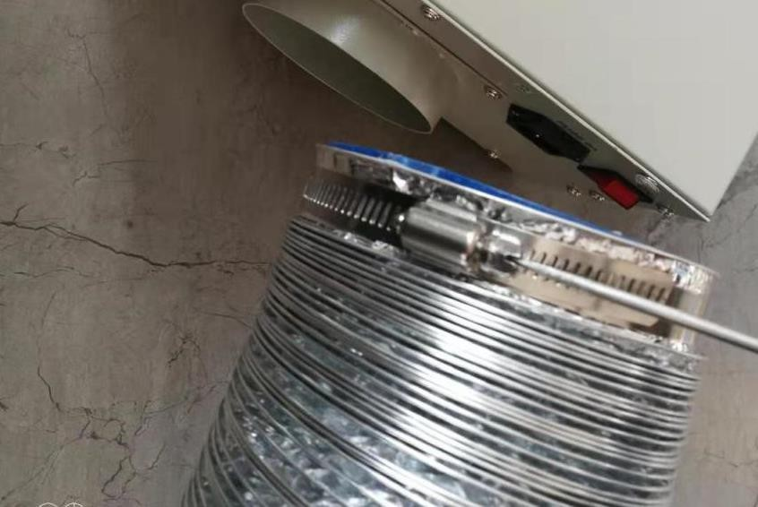
STEP 1 Loosen the screw on the fastening clamp of the exhaust pipe. (size of the exhaust pipe is Φ110mmx1500mm）

STEP 2 Put the exhaust pipe on the product interface, tighten the fastening screws.
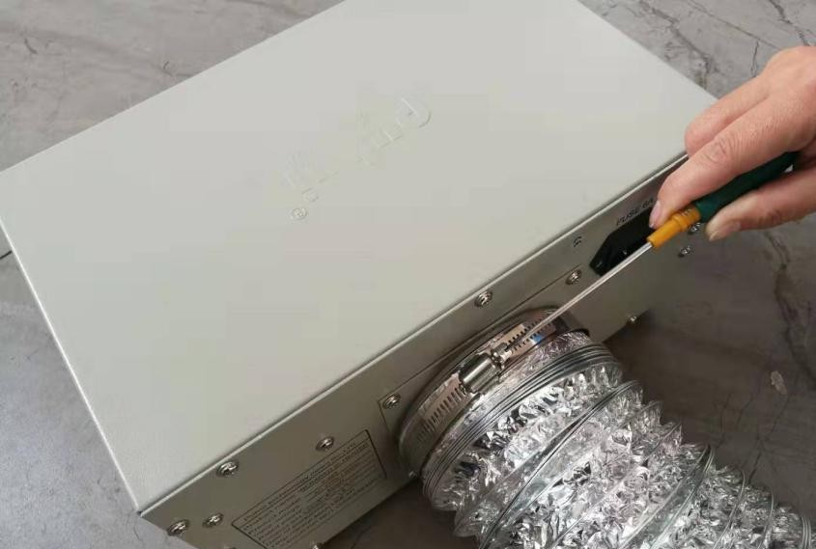
STEP 3Place the exhaust pipe outdoor.

MACHINE INTERFACE DESCRIPTION
STEP 1 Please put machine on the flat tabletop with good ventilation and no combustible items nearby. Reserve space for drawer-pull & push. And leave at least 20mm space around the machine, for heat dissipation. Also ensure smooth ventilation at the bottom.
STEP 2 Operation interface description
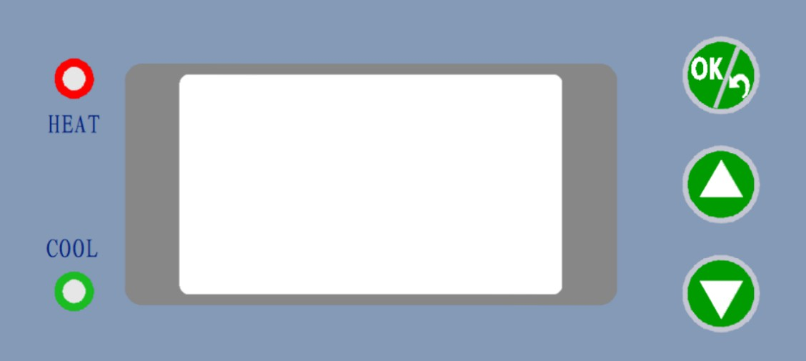

STEP 3 Power on the machine, then LCD shows as below:
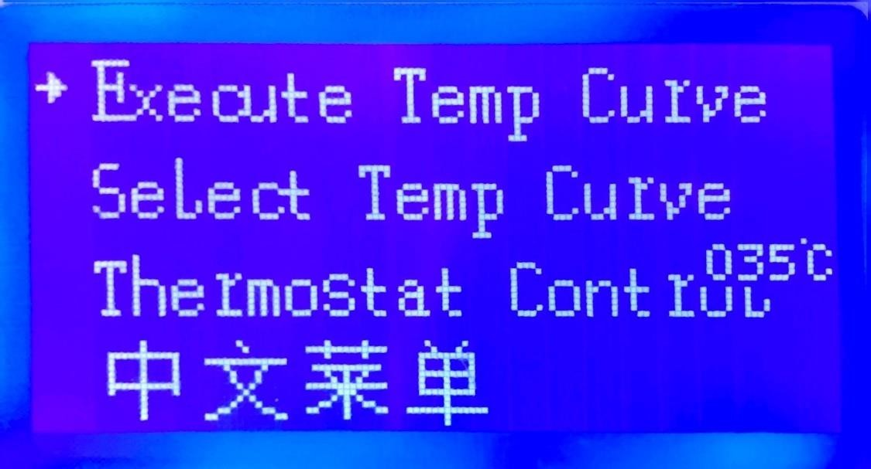
STEP 4 Press▲/▼Button to select functions, press OK/RETURN Button to execute functions or back to the main menu.

SPECIAL NOTE: If the picture in this user manual does not match the machine image, the machine image shall prevail.

EXECUTE TEMPERATURE CURVE
STPE 1 Press▲/▼Button to “Select Temp Curve”, then press OK/RETURN Button, the LCD will show as below:
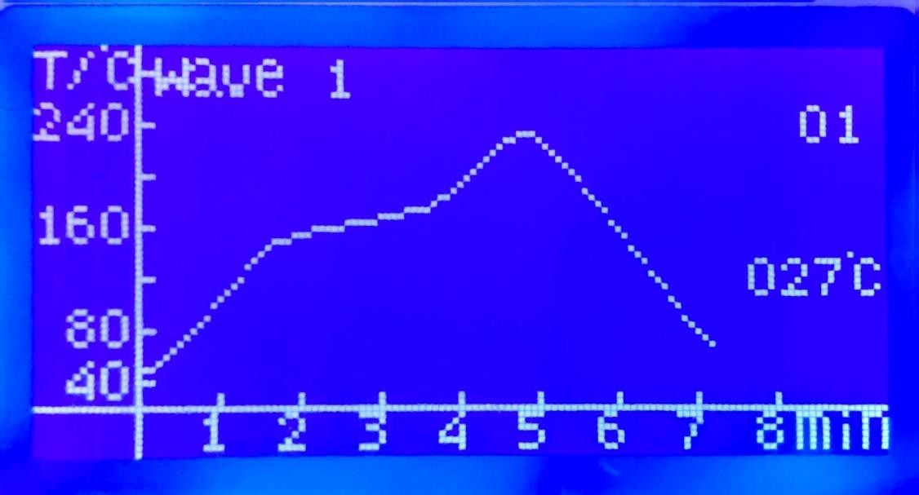
The initial curve is WAVE 1, press ▲ Button to switch to WAVE 2~WAVE 8.
WAVE 1 for 85Sn/15Pb 70Sn/30Pb; WAVE 2 for 63Sn/37Pb 60Sn/40Pb;
WAVE 3 for Sn/Ag3.5；Sn/Cu.75 Sn/Ag4.0/Cu.5; WAVE 4 for Sn/Ag2.5/Cu.8/Sb.5；Sn/Bi3.0/Ag3.0;
WAVE 5 for Standard Curing of Red Glue, Heraeus PD955M; WAVE 6 for PCB rework etc.
WAVE 7 and WAVE 8 are user-defined curve.

SPECIAL NOTE: The system will automatically switch to the following interface, if there is no any operation for 2~3 seconds. Press OK/RETURN Button to save the curve or back to the main menu.
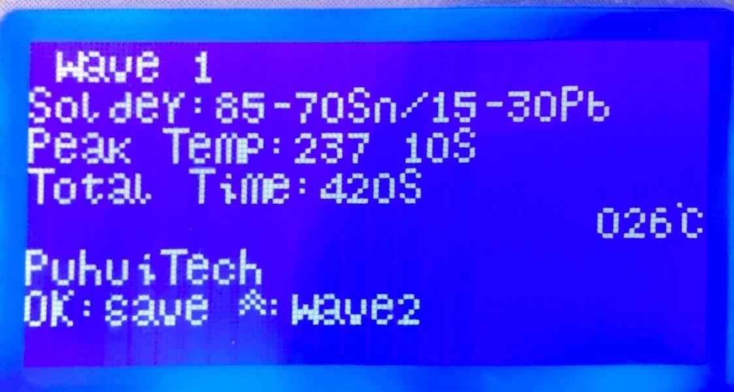
Press▲go to wave2
Press OK to Save Current Wave
Solder Type
Current Wave

STEP 2 After selecting curve, press OK/RETURN Button to return to the main menu. Select “Execute Temp Curve”, then press OK/RETURN Button to execute.

SELF-SET CURVE (INDEPENDENT OPERATION)
STEP 1 Select “Select Temp Curve”, then select WAVE 7 or WAVE 8. Press OK/RETURN Button enter the following editing interface:
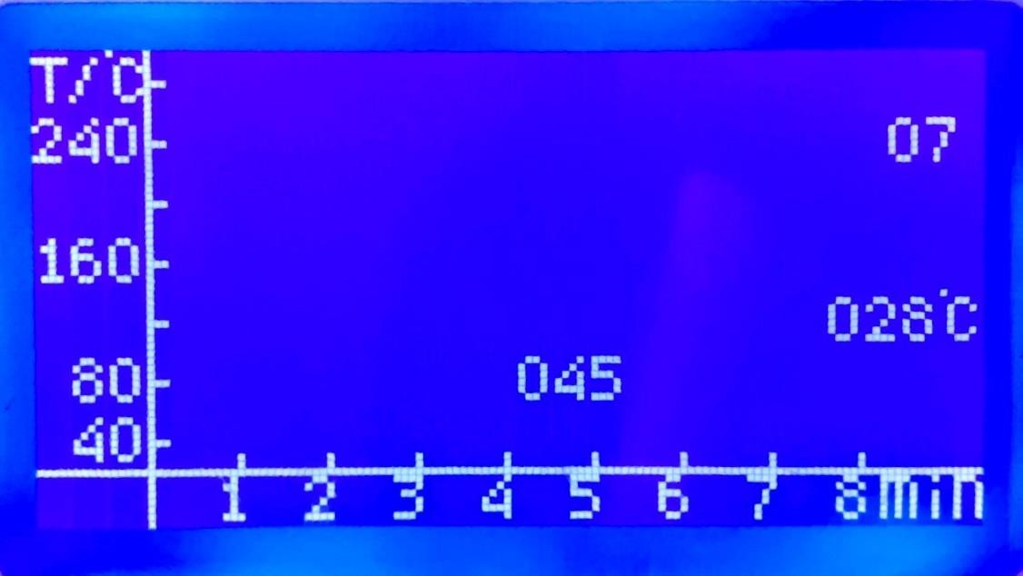
STEP 2 Press ▲/▼ Button to change the temperature value at current time.
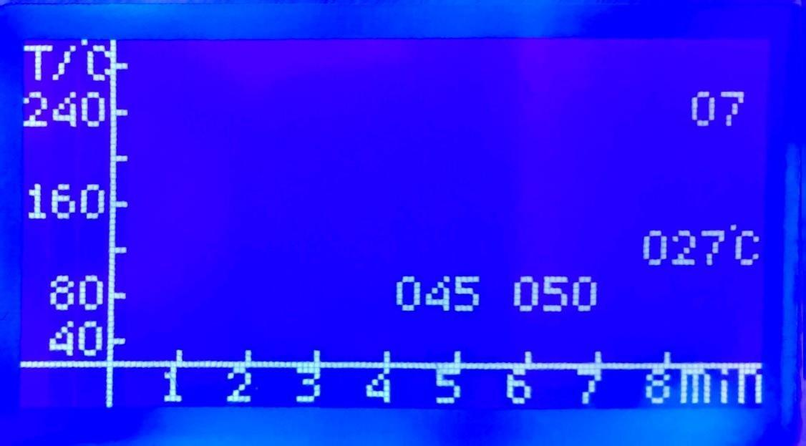
STEP 3 Press OK/RETURN Button to set the temperature value, then the system will automatically jump to the next time point. Each time point interval is 5 second.
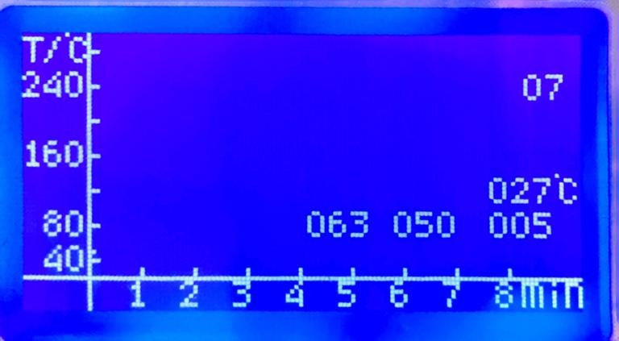

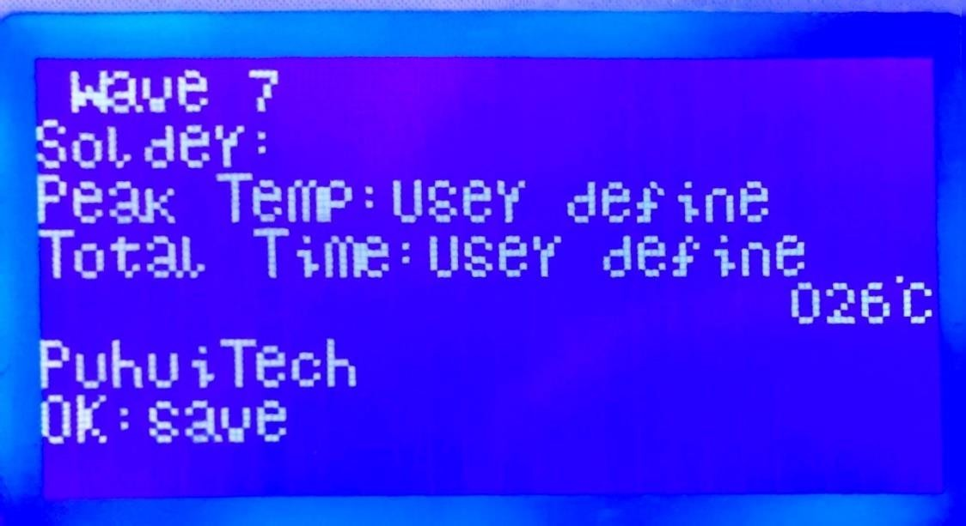
SPECIAL NOTE: The system will automatically switch to the following interface, if there is no any operation for 2~3 seconds. Press OK/RETURN Button will save the curve and back to the main menu.

STEP 4 When the temperature values at all time points are set, the new curve will be automatically saved and returned to the main menu.

SPECIAL MOTE: The settable time range of the self-set curve is: 0~480 seconds,

and the settable temperature range: 40~280°C. The software has a temperature protection function. If the temperature value set at the current time point is too high compared with the temperature value set at the previous time point, the setting cannot be successful.

SELF-SET CURVE (PC CONNETING)
STEP 1 Connect the machine with the computer using a serial cable.
STEP 2 Open the Excel form “temperature data”.

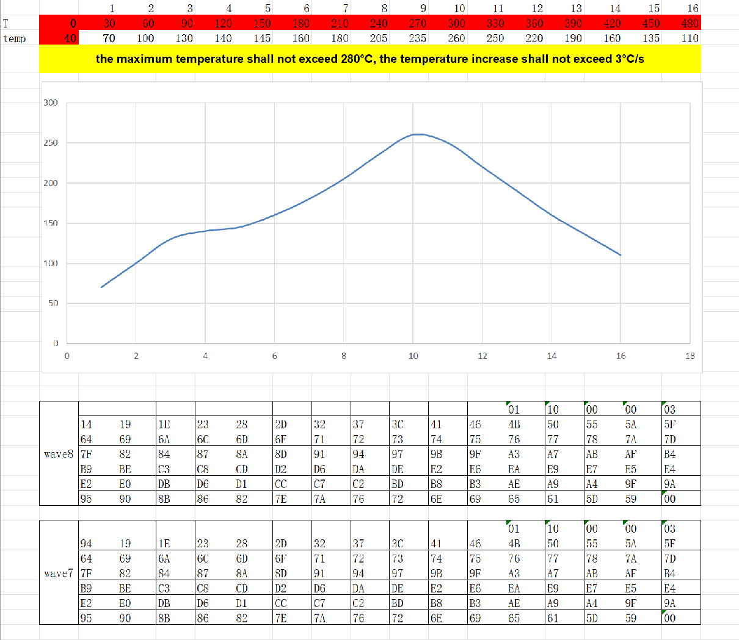
SPECIAL NOTE: The maximum temperature shall not exceed 280°C, and the temperature increase shall not exceed 3°C/s.
STEP 3 Double-click the unmarked temperature cell to modify the temperature value. STEP 4 After modifying all temperature values, click on the blank space or press the "Enter" key on the keyboard to refresh the data, and the newly generated temperature
curve will be observed. At the same time, the data in the two tables below will be updated.
STEP 5 Select and copy all data in the WAVE 7 or WAVE 8 table area.
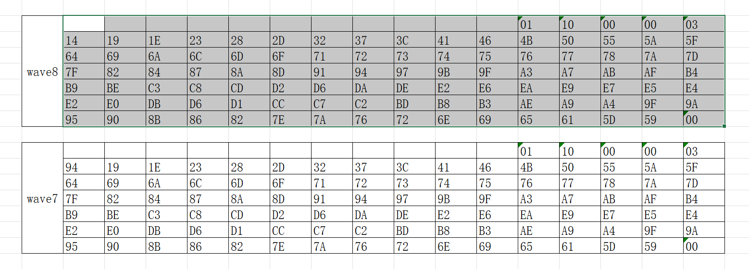

STEP 6 Open “SerialCom” software, it will show as below:
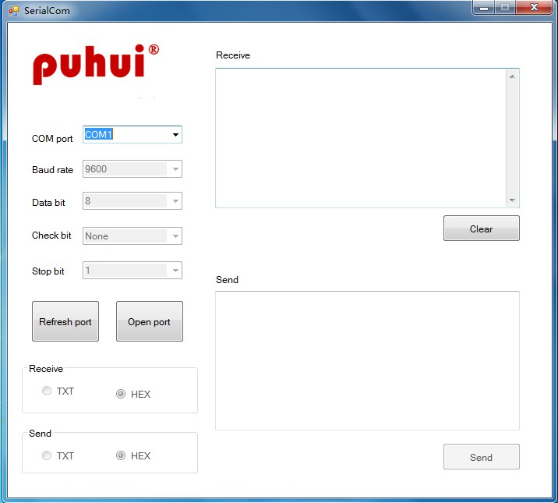

SPECIAL NOTE: Baud rate/ Data bit/ Check bit/ Stop bit/ Receive/ Send parameters do not need to be set.
STEP 7 Select the corresponding serial pot connected to the machine in the “COM port” drop-down list, then click the “Open port” Button. If there is any question about corresponding serial port, go to the “Control Panel” to check.
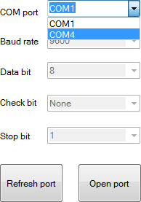
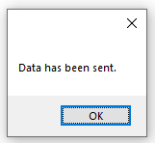
STEP 8 Copy the data in the WAVE 7 or WAVE 8 table set in the "temperature data" Excel form to the send area, then click the "Send" Button. When the data is sent successfully, a pop-up window will display. At the same time, machine will have a corresponding sound
prompt.
STEP 9 Unplug the serial cable and restart the machine.
STEP 10 Restart the machine, enter the "Select Temp Curve" interface, press ▲/▼ Button to select WAVE 7 or WAVE 8, it will show the new curve.

THERMOSTATIC CONTORL
STEP 1 Select the “Thermostat Control”, press the OK/RETURN Button enter into the operation interface.
STEP 2 Press ▲/▼ Button to set the temperature value (Temperature Range: 30~260°C)
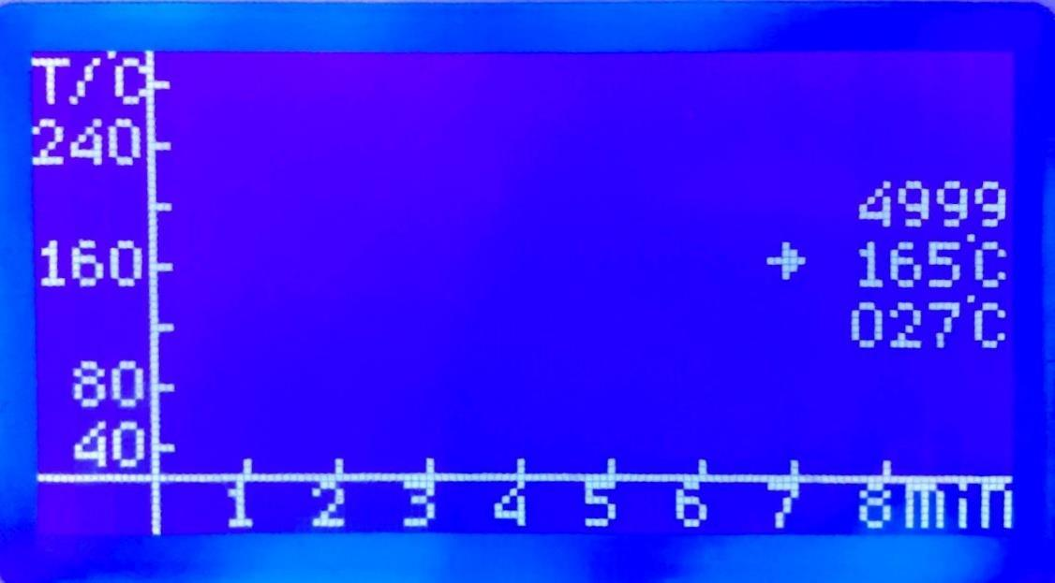
STEP 3 After setting the temperature value, press OK/RETURN Button to adjust the time.
STEP 4 Press ▲/▼ Button to set the time value (Time Range: 300~9999s)
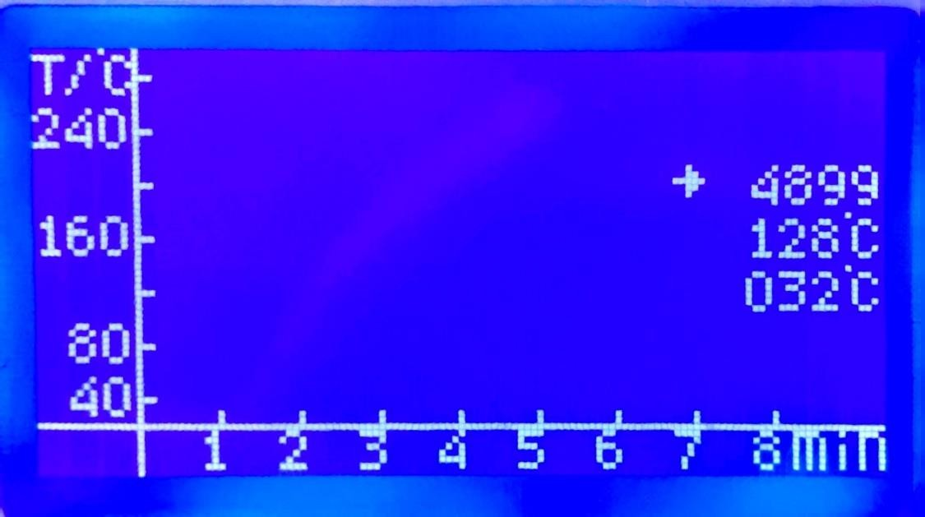
Step 5 After setting the time value, press OK/RETURN Button to execute the thermostatic control function. When the work done, the machine will stop automatically (the machine will beep when the process stops)

SPECIAL NOTE: When the machine is running the thermostatic control function, it can be stop by pressing the OK/RETURN Button at any time and back to the main menu.

OPERATING DETAILS
- Gently put the item to be processed on the flat surface in the drawer, close the drawer, then select the desired function and press OK/RETURN Button to execute. The LCD shows as below:
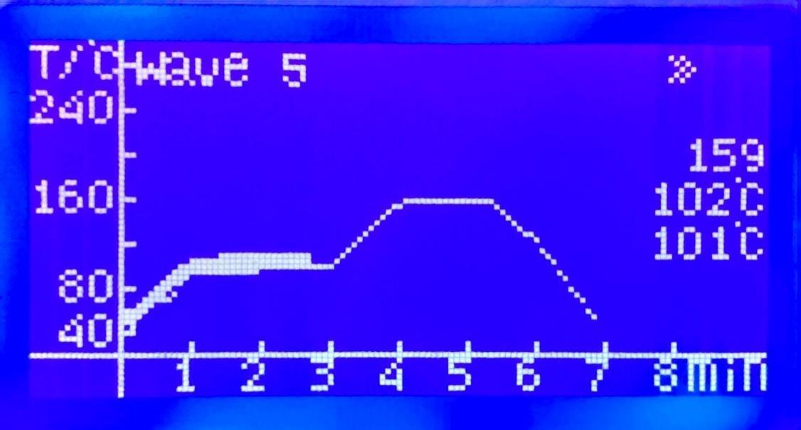
- The process will be done automatically under your supervision through the front window & the LCD data. (If the actual measured temperature value differs greatly from the set temperature value, the machine may alarm to prompt.)
- Press OK/RETURN Button can force the machine to stop at any time, if necessary.
- After the processing is completed, the fan will cool the machine automatically.
- If the result is not as expected, it can be processed again.

SUGGESTIONS
- To satisfy the soldering of small boards, please place a 10x10cm PCB board under it when soldering small-sized PCB boards and BGA balls to ensure soldering quality.
- Please preheat the machine when the environment is of low temperature or high humidity. The method: run the heating curve without placing any items.
- The chips with metal encapsulation of strong reflective material and the plastic inserts that withstand temperatures below 250°C cannot be soldered using this machine.
- The method to measure the temperature of the machine: use a standard thermometer to tightly fix the external temperature probe directly above the PCB, then put the PCB in the drawer, and push it into the machine for testing. The temperature measured in this way is more in line with the actual situation during machine processing.

MAINTENANCE
- The machine is equipped with an inner cavity cleaning function: after using it a few times, please run the heating curve without any components to allow the residual solvent and solder to evaporate. To ensure the inner cavity is clean and the performance of the whole machine is stable.
- Before shutting down the machine, please make sure the machine is cooling down sufficiently, to prolong the service life of the machine.
- Regularly clean the observation window in front of the machine to keep it clean.

- ATTENTIONS
1、Please make sure the machine is reliably grounded, and disconnect the machine from the mains when it is not in use for a long time.
2、The thermal insulation material of the machine has been strictly protected, it is not allowed to disassemble the machine without protection.
3、Due to technological innovation and product upgrading, etc., if the pictures and
software operations shown in this manual are inconsistent with the real thing, the real thing shall prevail.
4、For more detailed information and technical support, please go and visit the website www.te168.com for consultation.

